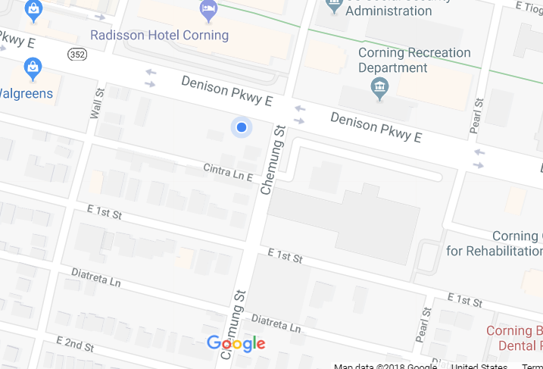
Parking
Health Education Center
Directions to: Corning Community College, Health Education Center, 132 Denison Parkway East, Corning, NY 14830
From North
Take I-390 south to I-86 East, exit 47. Turn right at exit, then left (west) onto Route 352. At Chemung Street, turn left. The Health Education Center is the building on the right corner. Just past the building, turn right into the parking lot. If this lot is full, continue on Chemung Street, past the stop sign at First Street and make a left turn into Diatreta Lane and then a quick left into the CCC parking lot.
From West
Take I-86, exit 46. Turn right onto Route 414S and proceed to Denison Parkway (Route 352). Turn left onto Denison Parkway. After two blocks, turn right on Chemung Street. The Health Education Center is the building on the right corner. Just past the building, turn right into the parking lot. If this lot is full, continue on Chemung Street, past the stop sign at First Street and make a left turn into Diatreta Lane and then a quick left into the CCC parking lot.
From East
Take I-86, exit 47. Turn right at exit, then left (west) onto Route 352. At Chemung Street, turn left. The Health Education Center is the building on the right corner. Just past the building, turn right into the parking lot. If this lot is full, continue on Chemung Street, past the stop sign at First Street and make a left turn into Diatreta Lane and then a quick left into the CCC parking lot.

